**ABSTRACT TEMPLATE: The First ISRM Commission Conference on**

**Estimation of Rock Mass Strength and Deformability – Lima, Peru, 2024**

**< Abstract Title >**

<Author name format - First name Middle initials Last name>

[E.g. Sam R. K. Perera1, Adam Perera1, Randy D. Chris2*]

1 Institution name, Country.

2 Institution name, Country.

*Corresponding Author: E-mail: username@domain

Telephone number: +Country Code-Number [e.g. +01-123456789]

**Topical Area:** <Select one from the given Topical Areas on the website; if your title does not belong to any of those, select “Other”>

**Introduction and Motivation:**[Left aligned]

Background information, requirement and importance of the study. [justified body text]

**Objective of the study:**[Left aligned]

Describe concisely what the study is trying to achieve. [justified body text]

**Methods & Procedures:** [Left aligned]

Specifically state how the study was conducted. [justified body text]

**Results:**[Left aligned]

State the specific outcomes from the study. [justified body text]

**Conclusions:**[Left aligned]

Indicate what can be concluded based on the outcomes of the given study. [justified body text]

**\* Abstracts should be submitted ONLY as MS-WORD documents**

Additional information on **font type, size and text alignment**

|  |  |  |
| --- | --- | --- |
| **Item** | **Information** | **Alignment** |
| Font type (with line spacing) | Book Antiqua (1.15) |  |
| Title | <Font Size-18-**bold**-Sentence Case> | Center |
| Author names | <Font Size-12> | Center |
| Affiliations | <Font Size-11> | Center |
| Corresponding author & email |
| Topical Area | <Font Size-12> | Left |
| Introduction and Motivation | Headings: <Font Size-11-**bold**>  Body text: <Font Size-11> | Headings: Left aligned  Body text: Justified |
| Objective of the study |
| Methods & Procedures |
| Results |
| Conclusions |
| Figure and Table Captions | <Font Size-09> | Center |
| Table content | <Font Size-10> | Center |
| Equations | <Font Size-10> | Center |

Additional information on **figures**

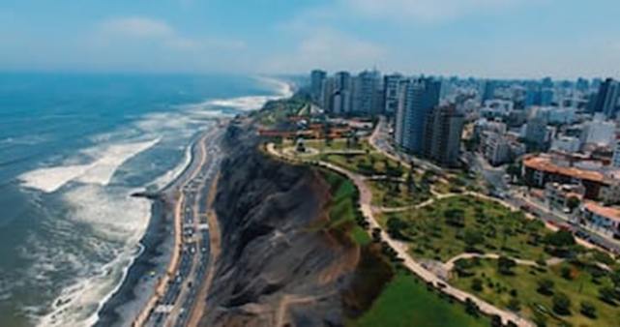

Figure 1: Aerial view of the location <Font Size-09>

Additional information on **tables**

Table 1: Test results <Font Size-09>

|  |  |  |
| --- | --- | --- |
| Item | Value | Description |
| 1 | 0.1 | None |
| 2 | 0.2 | None |
| 3 | 0.3 | None |

* Tables should NOT be inserted as images.

Additional information on **equations**

$BI \text{- }1=\frac{σ_{C}}{σ_{T}}$ (Equation 1) <Font Size-09>